**EXPERIMENT#2**

**Aim: Design of binary adders and subtractors.**

**Exercise#1:** Design half adder and half subtractor shown in Fig. 1 and Fig. 2 using logisim simulator.

**Logic Diagram :**

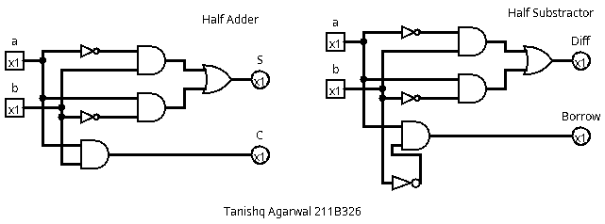

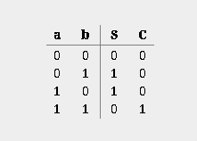**Boolean expression and Truth Table :**

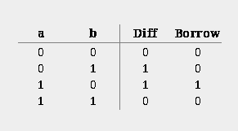**Half Substractor: Half Adder:**

S: ~a b + a ~b

Diff: ~a b + a ~b C: a b

Borrow: a ~b

**Exercise#2:** Design full adder using (i) basic gates only (ii) by adding half adder as sub circuit using logisim.

**Logic Diagram :**

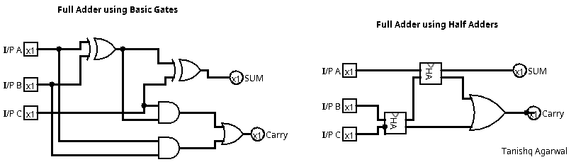

**Boolean expression and K-Map :**

**Exercise#3:** Design 4-bit binary adder using one half adder and 3-full adders as shown in Fig. 5. Use half adder and full adders as sub circuits in the design. Display both the input digits; output digit and end carry digit using Hex digit display with splitter available in logisim simulator.

**Logic Diagram:**

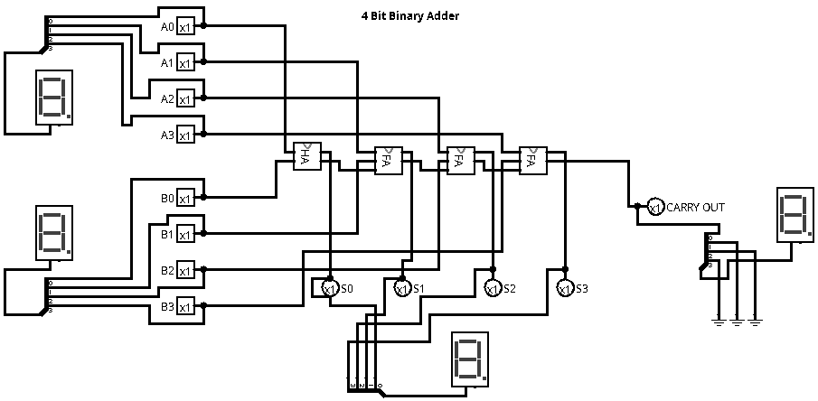**Boolean Expression and K-Map:**

**Exercise#4:** Design 4-bit binary adder-subtractor using full adders as shown in Fig. 6. Use full adders as sub-circuits in the design. Display both the input digits, initial carry digit; output digit, and end carry digit using Hex digit display with splitter available in logisim simulator.

**Logic Diagram:**  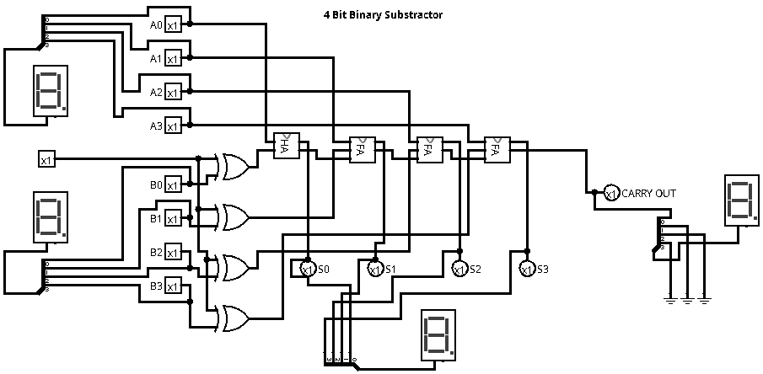

**Boolean Expressions & Truth Table :**